***Henshaw CE Primary School Newsletter***

**Newsletter No. 9 Spring Term 2024**

**Thursday 28th March**

**Bardon Mill**

**West Tyne Federation of Schools Hexham**

**Executive Headteacher— Mr Mike Glenton NPQH, MEd, BSc (Hons) NE47 7EP**

**Assistant Head Teacher Miss Michelle Munro BSc (Hons) Tel:01434 344324**

**A Message from the Head Teacher**

It has been a short half term (only four weeks and three days!) but what a lot the children have achieved and taken part in. It was lovely to see so many of you today at the Easter celebration and then returning to school to see the wonderful Easter egg entries – they were all fabulous!

We are all looking forward to the warmer weather and returning to our school field for playtimes. Thank you for continuing to ensure children bring coats in as the northern British weather (as we know) can be rather changeable.

We are hoping that the seasonal bugs and illnesses are finally over but can we please remind parents that if their child is absent from school, they inform the school office by email (to the [henshaw@westtynefederation.uk](mailto:henshaw@westtynefederation.uk) address) or by telephone by 9am. This allows us to meet our duty of care for all children in our care.

We have some new and exciting after-school clubs coming up next term as well as the return of some whole-class sporting events and our annual sports day; the date for this should be confirmed in the first few weeks of next term.

We hope you all have a lovely, restful Easter holiday

Best wishes, Mr Glenton

**Homework**

Can I take this opportunity to say a big thank you for your continued support for our homework projects and supporting your children in completing it to allow them to present it to their peers. We feel that the project-based approach to homework is really beneficial to our pupils; helping them to know more and remember more than a weekly worksheet would. The stories that the children have created and presented have been truly amazing and it has been wonderful to see their pride at presenting these to their friends!

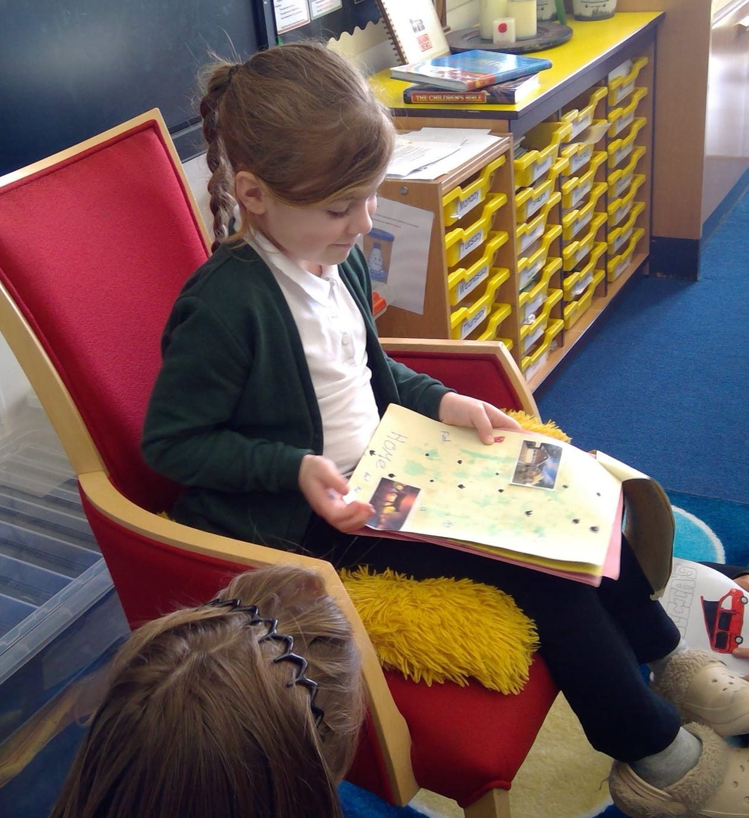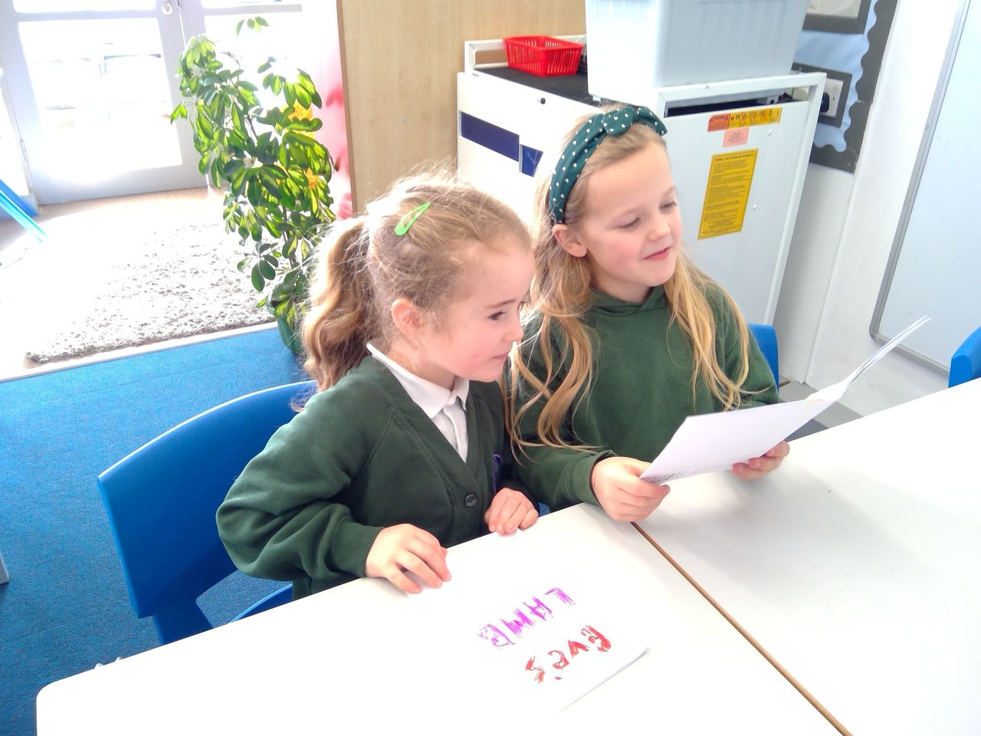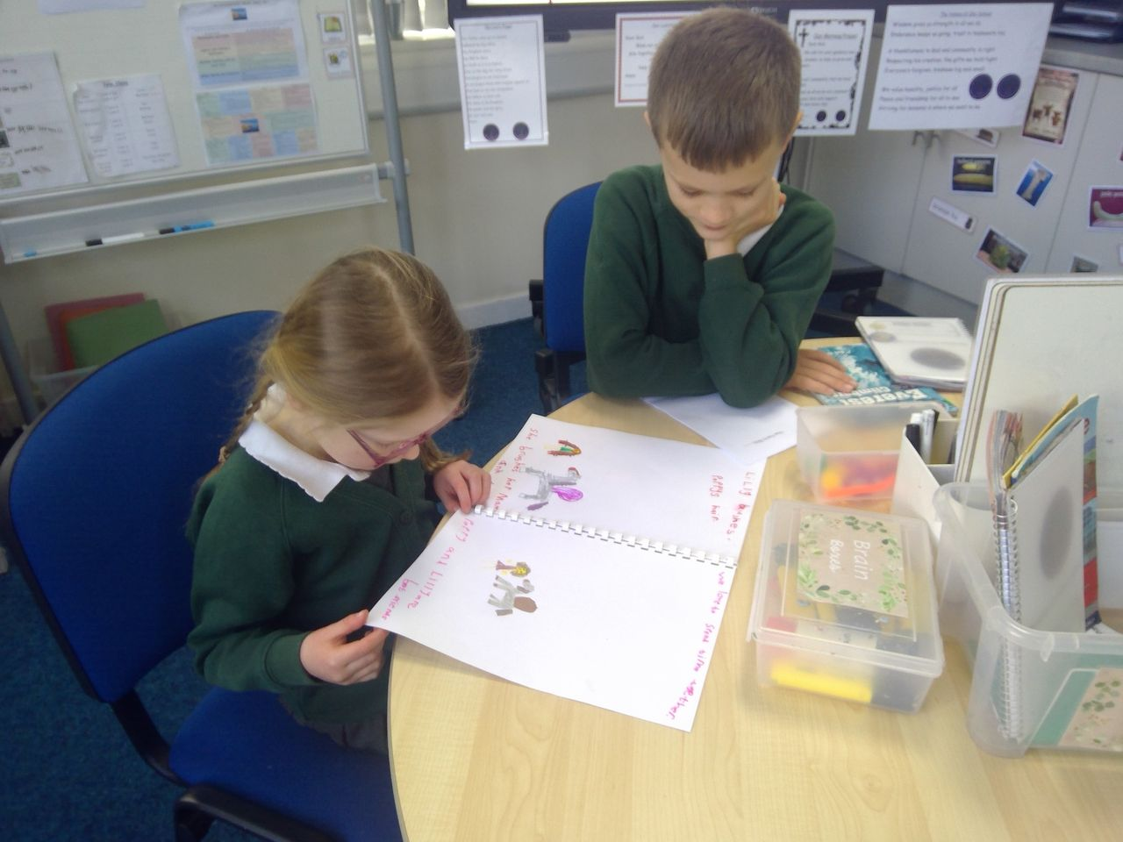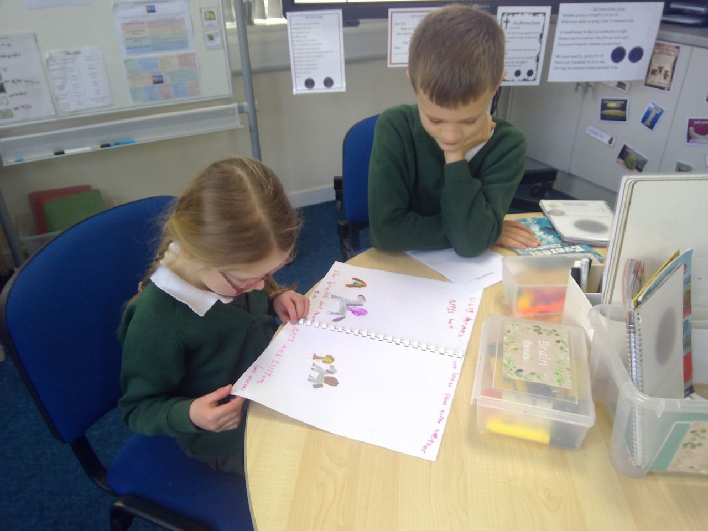

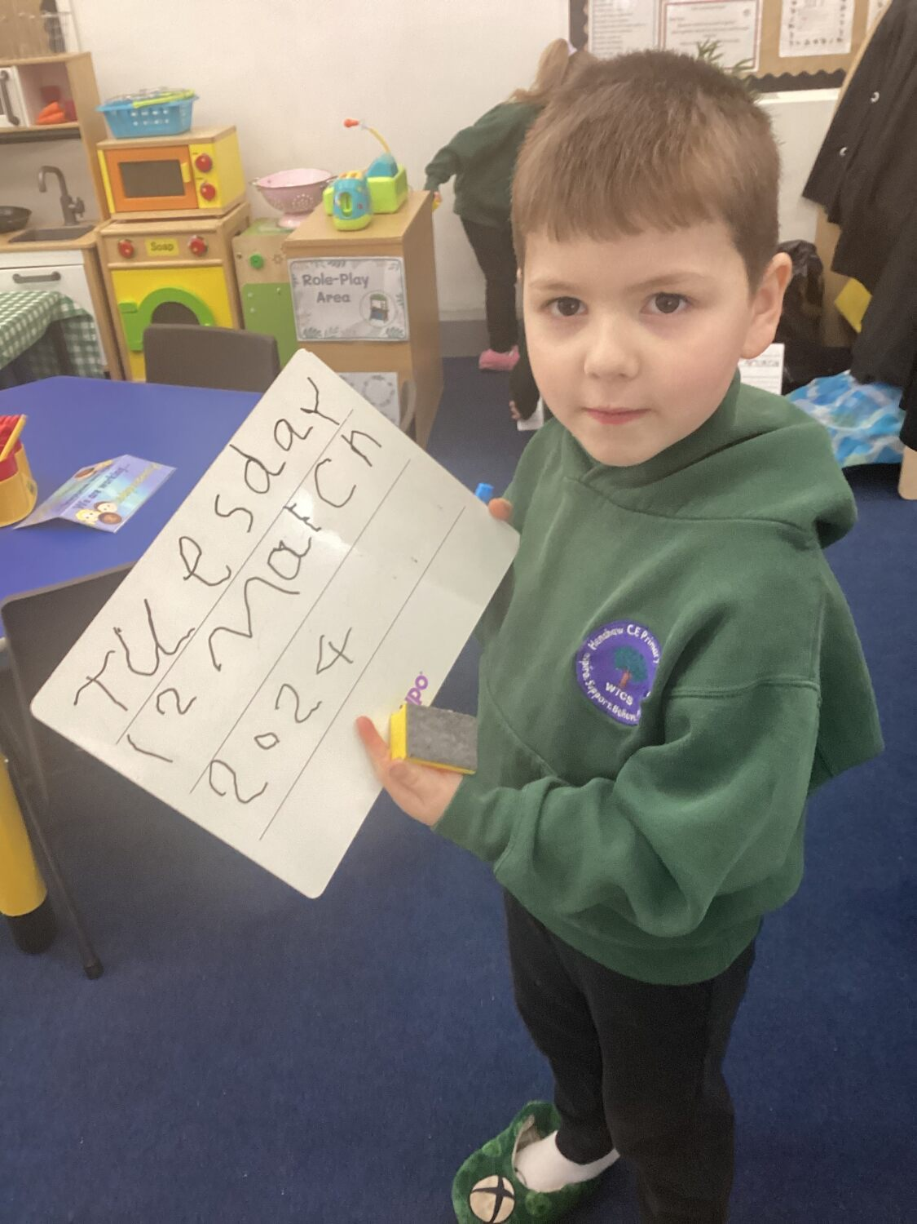

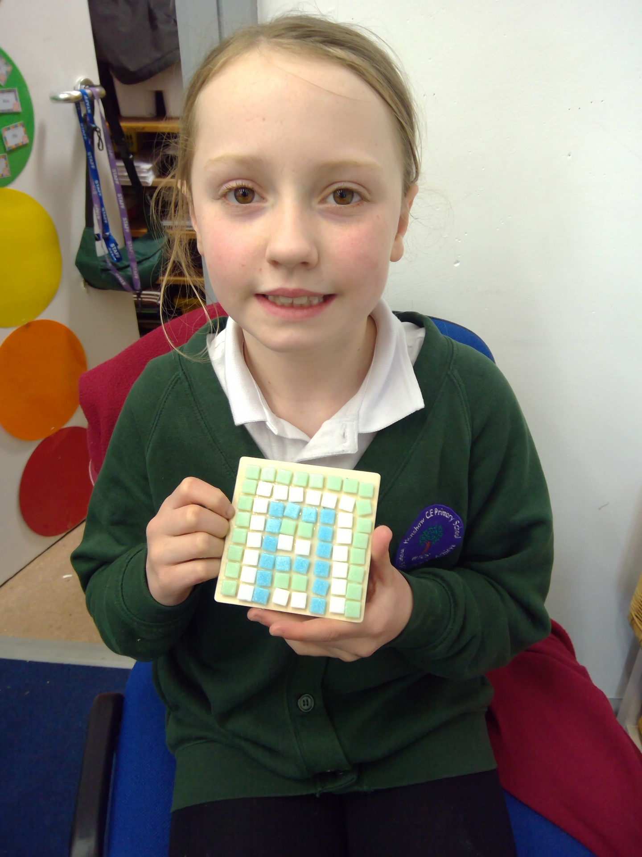

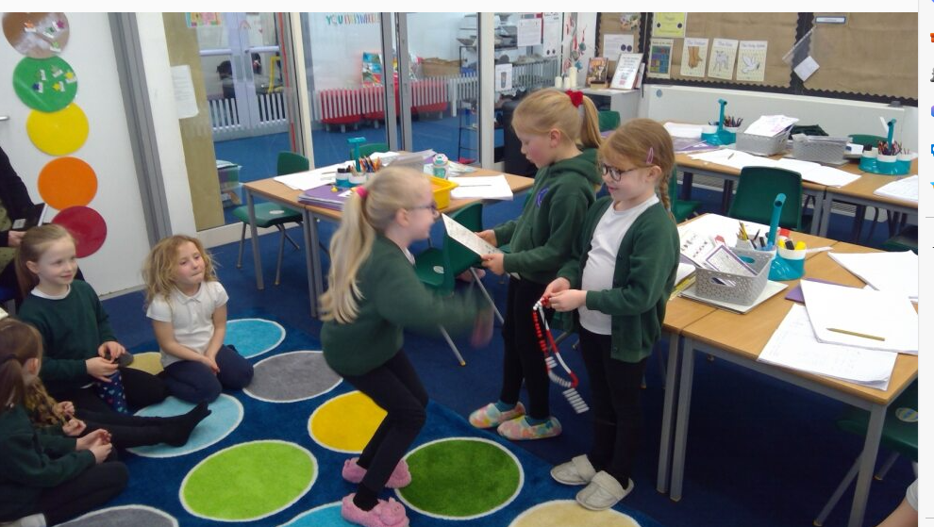

Nile Class

This week the children in Nile class have been exploring how to separate various materials which were mixed. They have used sieves, magnets, filter funnels and the evaporation process to separate mixtures. Can the children investigate what happens when an irreversible change occurs.

Rhine Class

It has been a very creative week in Rhine Class this week with mosaic making, dance festival practises and singing for the Easter celebration in Church.  We have completed sharing all of our wonderful stories with each other and we have also had the opportunity to share our Easter egg competition entries.  In English, we have completed our Newspaper articles and worked on spelling games and activities using Spelling Shed.  It is great to see so many children accessing this at home.  Every week, we are placed near the top of the federation league table.  In maths, we have been working on decimals in Year 4 and mass and capacity in Year 3.  We have also used technology to practice our multiplication tables - if your child could continue with this over Easter, it will really help - particularly our Year 4 children whose quiz is coming up in June.

Thames Class

 Thames class have been very busy this half term. Year 1 have been looking at the place value of numbers up to 50 and have become very confident with this. Looking for 2-digit numbers when they are out and about during the holidays would really help to consolidate their understanding. Year 2 have been finding a third of an object and an amount.  They have written some fantastic stories based upon the Smartest Giant by Julia Donaldson in English. However, the stories they wrote as their homework topic were amazing!!!  They have also worked hard practising their dance for the dance festival. I hope they demonstrate this for you at home.

Tyne Class  
In Tyne class we enjoyed listened to the story 'If I had a dinosaur' and we discussed what we would do if we had a dinosaur for a pet. We talked about what type of dinosaur we would like and what problems we might face having a dinosaur as a pet. The children used their phonic knowledge to write a sentence describing a pet dinosaur. In maths the children have been learning about number bonds. We are able to name number bonds to 5 and we are starting to develop an understanding of number bonds to 10. At home you can ask your child if they can describe a favourite dinosaur and ask for reasons why.

**Class News**



**Dance Festival**

Our second Dance Festival took place today at Haltwhistle Leisure Centre today and what an event it was! The children performed with such enthusiasm and it was great to see them collaborate so well with their peers to create their dance routines.

Our Dance Festival is one of our Federated events with our sister school, Greenhead Primary and, to ensure children do not feel too overwhelmed, we keep this as a closed event between the children and staff at the Federation. However, we will upload these dance routines to our Facebook pages so please take a look and enjoy sharing them with your children, they really deserve all the praise you can give them for such fantastic moves!

**Our School Promise**

Our School Promise reminds us of our vision and values that we hold dear at The West Tyne Church Schools Federation.

Well done to the following children for achieving their awards:

**Learning Award – Robert and Cole**

**Resilience & Teamwork Award – Zane and Jayden**

**Etiquette Award – Emily and Ellie**

**Environmental Award – Alice**

**Kindness Award – Ed and Eva**

**Inclusion Award – Harry**

**Friendship Award – Aria**

**Role model Award – Richard**

**Dates for the Diary**

**Thursday 28th March** – Last day of school before Easter holidays

Easter holidays: Friday 29th March until Sunday 14th April

Year 3 and 4 will attend swimming lessons on a Tuesday after the Easter holidays, starting on **Tuesday 16th April**

**Monday 15th April** – First day of summer term

**Tuesday 23rd April** – Mini Netball tournament

**Monday 29th April** – Quad Kids event for Year 3 and 4

**Monday 6th May** – Bank Holiday – School Closed

**Friday 10th May** – Class photos

**Week commencing 13th May** – Year 6 SATS week

**Tuesday 21st May** – Year 2 Synagogue visit

**Monday 27th May to Friday 31st May** – Half Term week

**A final thought…**

**The great gift of Easter is hope**

**Basil Hume**

**Easter Service and Egg competition winners**

Our first Easter Celebration was held at All Hallows today and the children sang beautifully and presented the story of Easter well to our audience of parents and family members.

When we arrived back at school, it was lovely to hear all the positive comments from our community about the work the children had done to produce their Easter egg designs. Thank you for supporting our local charity, St Oswalds, by making a donation for an entry fee; all proceeds will go towards this vital charity and we are happy to say we raised £73.50. Well done to all who entered and the winners pictured below; all children who entered received a chocolate egg.

