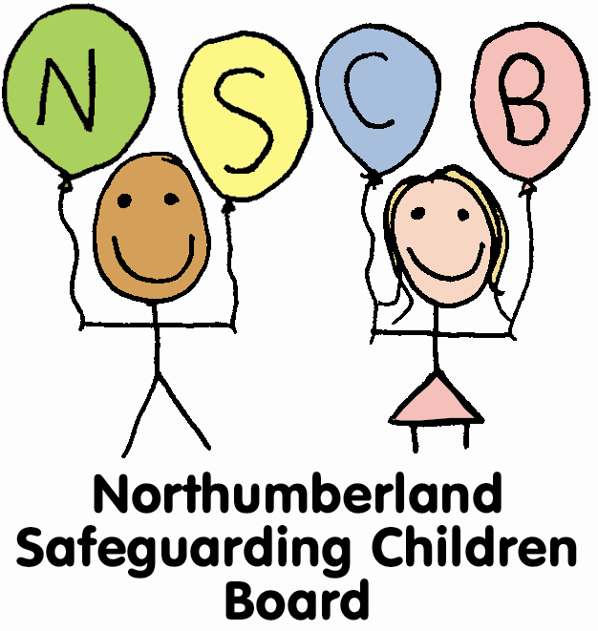

WEST TYNE FEDERATION SAFEGUARDING AND CHILD PROTECTION POLICY

Our Vision..... “Alone we can do so little, together we can do so much” Helen Keller Our Mission......
Our mission is founded on Christian beliefs and values to serve our local communities and wider community through providing the best possible education in the West Tyne Federation.
Our schools are committed to the personal development of all involved and aim to provide life- long learning.
We aim to provide extended facilities in our schools in order to support each child on their learning journey.

INTRODUCTION

The West Tyne Federation fully recognises its responsibility for safeguarding and promoting the welfare of children

Rationale

Our schools believe that pupils have a fundamental right to be protected from harm and that they cannot learn unless they feel secure. We also believe that all staff working in school have a right to personal support and guidance concerning the protection of pupils.

There are four main elements to our policy:

PREVENTION through the teaching and pastoral support offered to pupils and a whole school protective ethos.

PROCEDURES for identifying and reporting cases, or suspected cases, of abuse.

SUPPORT TO CHILDREN who may have been abused.

SAFER RECRUITMENT AND MANAGING ALLEGATIONS AGAINST STAFF
Our policy applies to all staff and volunteers working in the school including community education staff and governors. Teaching assistants, mid-day supervisors, secretaries as well as teachers can be the first point of disclosure for a child.

- PREVENTION

  - We recognise that high self-esteem, confidence, supportive friends and good lines of communication with a trusted adult helps prevention. We will therefore raise awareness of child protection issues and equip children with the skills to keep them safe.

  - The school will therefore:

    - establish and maintain an environment and positive ethos where children feel secure, supported and are encouraged to talk, are listened to, can learn, develop and feel valued;

    - ensure children know that there are adults in the school whom they can approach if they are worried or in difficulty;

    - include in the curriculum, activities and opportunities for PSHE which equip children with the skills they need to stay safe from abuse and to know to whom to turn for help;

    - include, in the curriculum, material which will help children develop realistic attitudes to the responsibilities of adult life, particularly with regard to child care and parenting skills

- PROCEDURES

  - We will follow the procedures set out in Interagency Procedures produced by the Northumberland Safeguarding Children Board, and in ‘Working Together’ 2013

  - The school will (in accordance with the Education Act 2002 and Keeping Children Safe in Education (2016)):

    - ensure it has a designated senior member of staff for child protection who has undertaken appropriate training. The training should be updated every two years. There are contingency arrangements should the designated member of staff not be available.

    - recognise the importance of the role of the designated person for child protection and arrange support and training.

2.2.3. ensure every member of staff (including temporary and supply staff and volunteers, and on-site contracted services) and every governor knows:

      - the name of the designated person and her/his role

      - that they have an individual responsibility for referring child protection concerns using the proper channels and within the timescales set out in the NSCB procedures

      - where the school’s Child Protection Procedures and the NSCB procedures are located

      - ensure that parents have an understanding of the responsibility placed on the school and staff for child protection by setting out its obligations in the school brochure

2.2.4 provide training for all staff from the point of their induction, and updated every three years at a minimum, so that they know

- their personal responsibility,
- the NSCB procedures,
- the need to be vigilant in identifying signs of abuse
- how to support and to respond to a child who tells of abuse

2.2.5. undertake appropriate discussion with parents prior to involvement of another agency unless the circumstances preclude this.

2.2.6. notify the local children’s social care team if:

      - it should have to exclude a pupil who is subject to a Child Protection Plan (whether fixed term or permanently)

      - if there is an unexplained absence of a pupil who is subject to a Child Protection Plan of more than two days duration from school (or one day following a weekend or as agreed as part of any child protection or core group plan)

2.2.7 work to develop effective links with relevant agencies and co-operate as required with their enquiries regarding child protection matters including attendance and written reports at initial child protection conferences, core groups and child protection review conferences;

2.2.8. keep clear detailed written records of concerns about children (noting the date, event and action taken), even where there is no need to refer the matter to the locality team immediately;

2.2.9. ensure all records are kept secure and in locked locations;

2.2.10. ensure that all staff and volunteers recognise their duty and feel able to raise concerns about poor or unsafe practice in regard to children and that such concerns are addressed sensitively and effectively in a timely manner in accordance with agreed whistle blowing policies

- SUPPORTING CHILDREN AT RISK

  - We recognise that children who are abused or witness violence or abuse may find it difficult to develop a sense of self-worth and may not see the world as a safe place or see adults as safe people they can trust. They may feel helplessness, humiliation and some sense of self-blame.

  - The school may be the only stable, secure and predictable element in the lives of children at risk. Nevertheless, when at school their behaviour may be challenging and defiant or they may be withdrawn.

  - We recognise that some children actually adopt abusive behaviours and that these children must be referred on for appropriate support and intervention and will need to support them in accordance with his/her agreed child protection plan.

  - The school will endeavour to support the child through:

    - the content of the curriculum to encourage self esteem and self motivation (see section 2);

    - the school ethos which (i) promotes a positive, supportive and secure environment (ii) gives pupils a sense of being valued (see section 2);

    - the school's behaviour recognises the need to support vulnerable pupils in the school. All staff will agree on a consistent approach, which focuses on the behaviour of the child but does not damage the pupil's sense of self worth. The school will endeavour to ensure that the pupil knows that some behaviour is unacceptable but s/he is valued and not to be blamed for any abuse which has occurred;

    - liaison with other services which support the pupil such as targeted support services, CYPS, local Children’s Social Care teams, Local Inclusion Support Teams (LISTs), school health etc;

    - a commitment to develop effective and supportive relationships;

    - recognition that children living in a home environment where there is domestic violence, drug or alcohol abuse are vulnerable and in need of support and protection;

    - vigilantly monitoring children’s welfare, keeping records and notifying the local Children’s Services social care team as soon as there is a concern;

    - transferring information of a pupil subject to a Child Protection Plan to a new school immediately should that child leave the school.

- ENSURING SUITABILITY OF ADULTS WORKING WITH CHILDREN

  - Compliance with the Disclosure and Barring Service 2012 (previously Vetting and Barring Scheme 2009)
  - The school will ensure that any disciplinary proceedings against staff relating to child protection matters are concluded in full even when the member of staff is no longer employed at the school and that notification of any concerns is made to the relevant authorities and professional bodies and included in references where applicable.

  - The school will ensure that all staff and volunteers are aware of the need for maintaining appropriate and professional boundaries in their relationships with pupils and parents.

  - The school will ensure that staff and volunteers are aware that sexual relationships with pupils aged under18 are unlawful and will be referred to the Police and LADO for investigation (Sexual Offences Act 2003).

  - The school will promote an e-safety policy and when appropriate seek guidance and support from the Local Authority e-safety officer (John Devlin).

  - The school will promote responsible use of social networking sites by education staff. Please refer to Circular letter (G10-11) 9th January 2011
(Safer Working Practices for Adults)

  - For advice on dealing with indecent or potentially illegal images of children
please see Appendix E.

OTHER RELEVANT POLICIES

  - Physical Intervention

    - Our policy on physical intervention by staff is set out in a separate document, is reviewed annually by the governing body, and is influenced by the DfE publication ‘Use of reasonable force 2013’. We acknowledge that staff must only ever use physical intervention as a last resort, and that at all times it must be the minimal force necessary to prevent injury to another person.

    - We understand that physical intervention of a nature which causes injury or distress to a child may be considered under child protection or disciplinary procedures.

  - Anti-Bullying

Our policy on anti-bullying is set out in a separate document and is reviewed annually by the governing body. We acknowledge that to allow or condone bullying may lead to consideration under child protection procedures.

  - Racist Incidents

Our policy on racist incidents is set out in a separate document and is reviewed annually by the governing body. We acknowledge that repeated racist incidents or a single serious incident may lead to consideration under child protection procedures.

  - Health & Safety

Our Health & Safety policy, set out in a separate document, is reviewed annually by the governing body. It reflects the consideration we give to the protection of our children both within the school environment and when away from the school when undertaking school trips and visits.

  - Children with additional needs

We recognise that statistically children with behavioural difficulties and disabilities are vulnerable to abuse. School staff who deal with children with profound and multiple disabilities, cerebral palsy, sensory impairment and or emotional and behaviour difficulties are particularly sensitive to signs of abuse.

(Note: It will be important that the policy of Special Schools and mainstream schools with units recognise the vulnerability of children with additional needs, particularly the needs of those with communication difficulties)

Confidentiality and Information Sharing

    - Staff will ensure confidentiality protocols are adhered to and information is shared appropriately. If in any doubts about confidentiality, staff will seek advice from a senior manager or outside agency as required.

    - The Head Teacher or designated person will disclose any information about a pupil to other members of staff on a need to know basis only.

    - All staff must be aware that they have a professional responsibility to share information with other agencies in order to safeguard children.

    - All staff must be aware that they cannot promise a child or an adult to keep secrets/confidences/disclosures.

GOVERNING BODY CHILD PROTECTION RESPONSIBILITIES

  - The governing body fully recognises its responsibilities with regard to child protection and to safeguarding and promoting the welfare of children.

  - It will:

    - designate a governor for child protection who will oversee the schools child protection policy and practice and champion child protection issues

    - ensure an annual report is made to the governing body on child protection matters to include changes affecting CP policy and procedures, child protection training received, the number of incidents/cases (no names) and child protection in the curriculum

    - ensure that this policy is annually updated and reviewed

  - If the governing body provides extended school facilities or before or after school activities directly under the supervision or management of school staff, the school’s arrangements for child protection as written in this policy shall apply.

  - Where services or activities are provided separately by another body the governing body will seek assurance that the body concerned has appropriate policies and procedures in place for safeguarding children and child protection and there are arrangements to liaise with the school on these matters where appropriate.

  - If another organisation uses the school premises as part of a letting arrangement then the school will require copies of that organisation’s child protection procedures before the letting commences.

Missing from Education

To view Northumberland County Council’s policy on reducing the risk of children going missing from education please see Appendix D.

Promoting E-safety in Northumberland Schools.

A comprehensive booklet about e-safety and children is available to download on the Safeguarding area of the Northumberland County Council website and Northumberland’s grid for learning.

Our designated member of staff with responsibility for Child Protection issues is:
Sarah Hutchinson, Headteacher
Last trained June 2015

Deputising arrangements if absent or unavailable

Joanne Fairless, Teacher
Debbie Clarke, Senior Teacher
Last trained March 2015

E-Safety
Our E-Safety Co-ordinator is: Joanne Fairless, Teacher

Safer Recruitment and Selection on-line training

One member of the selection panel for staff appointments must have completed either the on-line or face-to-face safer recruitment training

Judith Meek, Acting Headteacher

November 2016

This policy will be reviewed November 2017.

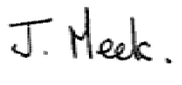
Judith Meek

Acting Head teacher

APPENDICES

Appendix A Contacts

Appendix B Standards for effective child protection practice in schools

Appendix C Frequently asked questions

Appendix D Children who go missing from education

Appendix E Dealing with indecent or potentially illegal images of children

Appendix F Dealing with allegations against people who work with children

Appendix G School Child Protection Files – a guide to good practice

Appendix H Further references

Appendix A

Contacts
Advice Area | School Contact(s)
Discussion about a CP or child welfare referral | Through school to children’s social care teams:  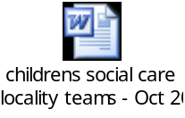
Advice on the operation of CP/Safeguarding Procedures , how to refer and where | Steve Day – Safeguarding Standards Manager & Principal Social Worker – 01670 624037  Or Independent Reviewing Officers  01670 623965
Lead roles in relation to responding to allegations against staff (including those not employed by school) | Chris O’Reilly – Local Authority Designated Officer (LADO) to deal with allegations against people who work with children (click on link to open info sheet and flow chart) – 01670 623979  Lynsey Willis (01670 623603)  or Ian Harbottle (01670 623605) re school staff  Hugh Cadwallader (01670 623126) for centrally employed education staff
CP Allegations relating to school transport | Chris O’Reilly LADO (01670 623979)
Model CP Policy for schools | Jane Walker (01670 622734)
Policy on use of restraint in schools | Chris Farley (01670 624184)
Recruitment and Selection/Vetting and Barring | Lynsey Willis /Ian Harbottle/Hugh Cadwallader
Co-ordination of Training Requirements for Designated staff (CP) | Anne Lambert (01670 623159)
MAPPA – Risk Management re individuals who may pose a risk to children | Patrick Boyle/MAPPA (01670 624035)
Monitoring/Quality Assurance re operation of schools safeguarding arrangements | Jane Walker (01670 622734)
Children Missing from Education | Chris Farley (01670 624184)

Appendix B

Standards for Effective Child Protection Practice in Schools

A school should measure its standards with regard to safeguarding against the expectations of the Ofsted framework for the inspection of schools (section 5) and the arrangements of the Local Safeguarding Children’s Board (LSCB).

In best practice, schools:

- operate safe recruitment practices including ensuring appropriate DBS and reference checks are undertaken according to DfE guidance on safer recruitment, including the maintenance of a single central register of all staff (including volunteers) with DBS numbers and training record;

- have an ethos in which children feel secure, their viewpoints are valued, and they are encouraged to talk and are listened to;

- provide suitable support and guidance so that pupils have a range of appropriate adults to whom they can turn if they are worried or in difficulties;

- work with parents to build an understanding of the school’s responsibility to ensure the welfare of all children and a recognition that this may occasionally require children to be referred to investigative agencies as a constructive and helpful measure;

- are vigilant in cases of suspected child abuse, recognising the signs and indicators, have clear procedures whereby teachers report such cases to senior staff and are aware of local procedures so that information is effectively passed on to the relevant professionals;

- monitor children who have been identified as at risk, keeping, in a secure place, clear records of pupils’ progress, maintaining sound policies on confidentiality, providing information to other professionals, submitting reports to case conferences and attending case conferences;

- provide and support child protection training regularly to school staff every three years and in particular to designated teachers every two years to ensure their skills and expertise are up to date;

- contribute to an inter-agency approach to child protection by developing effective and supportive liaison with other agencies;

- use the curriculum to raise pupils’ awareness and build confidence so that pupils have a range of contacts and strategies to ensure their own protection and understand the importance of protecting others, taking into account sex and relationships guidance.
- provide clear policy statements for parents, staff and children and young people on this and on both positive behaviour policies and the schools approach to bullying;

- have a clear understanding of the various types of bullying - physical, verbal and indirect, and act promptly and firmly to combat it, making sure that pupils are aware of the schools position on this issue and who they can contact for support;

- take particular care that pupils with additional needs in mainstream and special schools, who may be especially vulnerable to abuse, are supported effectively with particular attention paid to ensuring that those with communication difficulties are supported to express themselves to a member of staff with appropriate communicative skills;

- have a clear policy about the handling of allegations of abuse by members of staff, ensuring that all staff are fully aware of the procedures and that they are followed correctly at all times, using the guidance ‘Keeping Children Safe in Education (2014)’

- have a written whole school policy, produced, owned and regularly reviewed by schools staff and which clearly outlines the school’s position and positive action in respect of the aforementioned standards.

Appendix C

Frequently Asked Questions

What do I do if I hear or see something that worries me?

Tell the designated member of staff or head teacher.
If that is not possible, telephone Children’s Services (Children’s Social Care Locality Team) as quickly as possible. (In an emergency call 999 for the police)

What are my responsibilities for child protection?

To know the name of your designated member of staff for Child Protection and who to contact if they are not available

To respond appropriately to a child
To report to the Designated Person
To record your concerns - ‘Don’t do nothing’

Can I go to find someone else to listen?

No. You should never stop a child who is freely recalling significant events.

Can I promise to keep a secret?

No! The information becomes your responsibility to share in order to protect. As an adult, you have a duty of care towards a child or young person

Can I ask the child questions?

No! Nor can you make judgements or say anything about the alleged abuser; it may be construed as contriving responses.

You can ask a child to repeat a statement.

Do I need to write down what was said?

Yes, as soon as possible, exactly what was said. (Date and signature)

Appendix D

Children who go missing from education

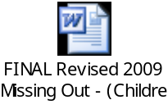

Appendix E

Dealing with indecent or potentially illegal images of children
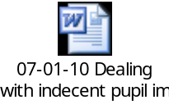

Appendix F

Dealing with allegations against people who work with children

What is a Local Authority Designated Officer or LADO?

The role of the LADO was initially set out in the HM Government guidance Working Together to Safeguard Children 2010 and continues in Working Together 2013.

Appendix 5 outlines the procedures for managing allegations against people who work with children, for example, those in a position of trust.

The LADO works within Children’s Services and should be alerted to all cases in which it is alleged that a person who works with children has:

- behaved in a way that has harmed, or may have harmed, a child
- possibly committed a criminal offence against children, or related to a child
- behaved towards a child or children in a way that indicates s/he is unsuitable to work with children.

This role applies to paid, unpaid, volunteer, casual, agency and self‐employed workers and all adults outside the school workforce. They capture concerns, allegations or offences; this can include concerns about their own personal life, e.g incidents of domestic violence or child protection concerns relating to their own family.

If there is an allegation against the Headteacher then concerns should be reported directly to the Chair of Governors and LADO.

The LADO is involved from the initial phase of the allegation through to the conclusion of the case. They will provide advice, guidance and help to determine whether the allegation sits within the scope of the procedures.

The LADO co‐ordinates information‐sharing with the right people and will also monitor and track any investigation, with the aim to resolve it as quickly as possible – see flow chart below.

The LADO for Northumberland is Chris O’Reilly.

Chris can be contacted by email or telephone:

Chris.O’Reilly@northumberland.gcsx.gov.uk
01670 623979

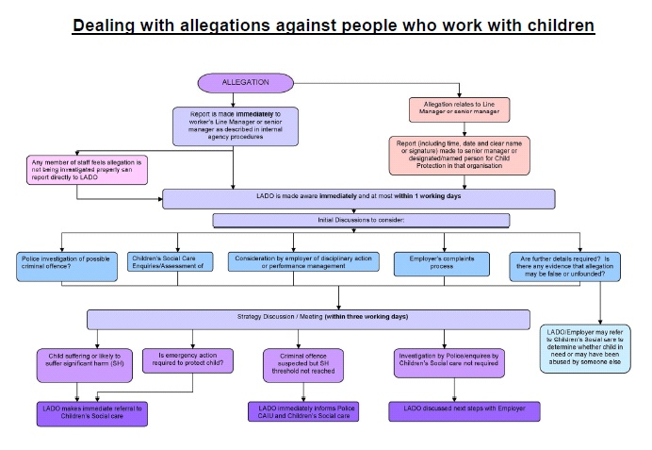

Appendix G

School Child Protection Files – a guide to good practice

Child protection file should include:
- Copy of referral form
- Minutes of strategy meetings
- Any written submission to a child protection conference / child protection plan review
- Minutes of child protection conference / child protection plan reviews
- Log of phone calls / contact with parent/carer and professionals

All safeguarding concerns raised with the DP (whether or not they require referral to Children’s Social Care) should be recorded. This should include any action taken by the member of staff raising the concern and also any action taken by the designated person (eg talking to child individually, contacting parents, taking advice from other professionals etc). These records should be kept, as with a child protection file, securely, separate to the child’s main school file.

At the point of transfer to another school, child protection records should be transferred directly from DP to DP, separate to the child’s main school file.

The main school file should have a ‘flag’ which shows that additional information is held by the DP.

Appendix H

Further references

For further information, advice and guidance please visit the Safeguarding web area of the Northumberland County Council website.

