English  Look at non-fiction, fiction or poetry books about cities. Read and enjoy them with an adult. (Dick Whittington, Town Mouse and Country Mouse, A walk in London, Spike in the City) | Geography  Draw a map of a city and direct a toy car or figure using words such as forwards, backwards, straight ahead, left, right, up, down, under and over. You can use numbers too if you like.
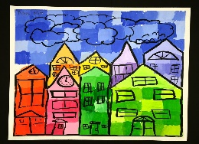  D/T  Make a cityscape artwork and share it with the class. | Research  Search the web with an adult to find images of different cities in the world. Create a scrapbook of your favourite cities and include pictures, labels and captions. Can you find and record a short fact about each city?
Music  Create a city song to the tune of The Wheels on the Bus. Your song should start with, ‘I went to the city, and I saw…’ | Maths  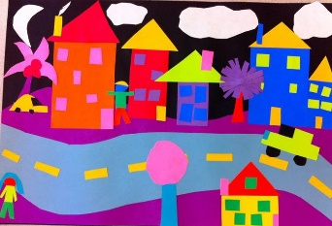  Create a 2-D city shape picture. Can you label the shape names? What are the properties of the shapes in your picture? (How many sides, how many corners?)
D/T  Build a real or fantasy city using Lego, blocks,or 3-D junk material from home. Play with your city using figures and vehicles. | Research  Spot and talk about different types of vehicles while you are out and about with your family.
English  Create and label a picture or map of a fantasy city. What type of buildings would be in your city and what would they look like? What transport would people use in  this city? Why would you like to live in your fantasy city? | English/D/T  Bake some bread and then write the instructions to tell a friend how to make it.  https://www.bbcgoodfood.com/recipes/easy-bake-bread
Children are asked to complete a minimum of three pieces of homework during the term. Please email me if you have any questions.
Thank you. Mrs Olsson and Miss Mowbray.

