English  Our class texts are books by William Shakespeare – our significant author.  Our guided reading text is ‘The River Prince’ by Saviour Pirotta.  Our writing styles for this half-term are:  - Non-chronological reports  - Persuasive writing  - Balanced arguments | R.E.  Our thematic learning in R.E. this half-term poses the question: Was Jesus the Messiah?  We will be identifying:  - What a messiah is and why it is important in some religions.  - What role Jesus plays in the true message of Christmas. |  |  | Maths  In Maths during this half-term, our objectives will focus on fractions as well as multiplication and division:  We will be learning to:  - identify multiples and factors.  - solve problems involving multiplication and division.  - identify, name, and write equivalent fractions.  - compare and order fractions.  - add and subtract fractions.  - use common factors to simplify fractions.  - multiply proper fractions by a whole number. |  |  | History  In History, we are finding out about the First World War and its impact on Britain.  We will be learning about:  The causes of the First World War.  - Why men volunteered to fight in the war.  - How trenches were used and why.  - What life was like during the First World War.  The impact of new weaponry.  - The end of the war.
PSHCE/RSE  This half term is all about ‘Celebrating the differences between the world we live in”.  We will be looking at:  - the differences between direct and indirect types of bullying and how to help myself and others.  - why racism and other forms of discrimination are unkind.  - explain how difference can cause conflict or celebration. |  | 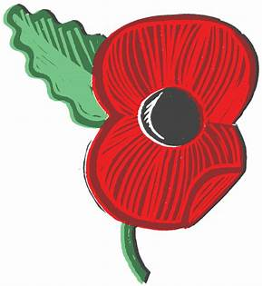  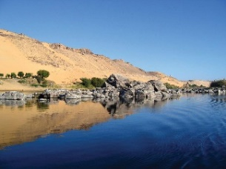  Nile - Curriculum Grid Autumn 2 - Y5.6 |  |  |  | Science  In Science this half-term, we will be working scientifically.  We will be learning to:  - plan different types of scientific enquiries to answer questions.  - take measurements, using a range of scientific equipment.  - use test results to make predictions to set up further comparative and fair tests.  - identify scientific evidence that has been used to support or refute ideas or arguments.
French  In French, this half-term, we will be learning about ‘My home’.  We will be learning to:  - say where I live using simple French phrases.  - say how many rooms I have in my house using simple French phrases. | D&T  In Design and Technology, this half-term, we are going to be focussing on recycling and repurposing old clothes – entitled - make do and mend, just like in WW1.  We will be learning to:  - explore a range of simple sewing stitches.  - recycle old clothes and materials to give it a new purpose.  - design and make items of clothing for a particular purpose, to perform a function. |  | Music  In Music, we will be receiving Ukulele lessons.  We will be learning to:  - hold the Ukulele in the correct position.  - Play the Ukulele by strumming and plucking the strings.  - learning a variety of chords on the Ukulele.  The music this term will be based around the preparation for our Christmas performance. We will also be taking part in whole school singing lessons. |  | Computing  In computing, we will be learning how to create vector drawings.  We will be learning to:  - use different drawing tools to help create images.  - recognise that images in vector drawings are created using shapes and lines, and each individual element in the drawing is called an object.  - layer their objects and begin grouping and duplicating them to support the creation of more complex pieces of work. |  |  | P.E.  In P.E. this half-term, we will be swimming at the Wentworth Centre. On Wednesdays, we will be taking part in Commando Joe sessions, focussing on team-building and problem-solving.  Swimming will take place each week on a Monday. Please can children come to school in their school uniform on Monday.  Children will need to come in their P.E. kits on Wednesday each week.

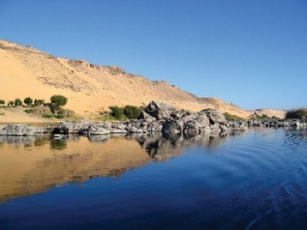
Links to our curriculum drivers Nile Class Autumn 1 Y5.6
Curriculum Driver | Links within our curriculum this half term
Christianity and Faith | - PSHCE – celebrating people’s differences – different faiths/beliefs/cultures  - Understanding why Christians believe Jesus was the Messiah  - Celebrating and commemorating Remembrance Day.  - Christmas Performance – The Christian value of humility and Forgiveness  - Christingle service at our local church
Our Local Area | - The impact of WWI on Britain and our local area.  - Celebrating Remembrance Day at Holy Cross and laying a wreath at our local memorial.  - Comparing life in WWI to life in our local community.
Outdoor Growing, Learning and Environment | - Eco Schools Representatives improving our school environment.  - Commando Joes – outdoor problem solving and learning
Wider World and Diversity | - PSHCE/RE – celebrating differences – diversity and stereotyping.  - Children in Need day  - School Council supporting local charities  - Understanding protected characteristics during Anti-bullying day  - World Cup day – Learning about traditions and cultures from another country
The following drivers underpin our school curriculum and, with our vision and values, allow us to deliver our curriculum strategy. These key drivers are personal to our schools and reflect the locational, social and educational needs of our community.

