Communication and Language
We will listen to and use spoken and written language to communicate our ideas in our play and learning. We will listen attentively to a range of stories related to our theme. We will accurately anticipate key events and respond to what we hear with relevant comments, questions or actions. We will join in with repetitive phrases. We will use language to imagine and recreate roles and experiences in our role play areas.
We will also be finding as many opportunities to speak in a variety of genre to a variety of audiences including talk partners, small group discussions, whole class discussions, whole school situations and for external audiences with our sharing of work assemblies for parents.
We will learn to focus attention for short spans and to listen attentively in a range of situations. We will listen to instructions and follow them accurately, asking for clarification if necessary, including those which contain several parts in a sequence.
We will learn new vocabulary related to our learning adventures. We will use talk to connect ideas, explain what is happening and anticipate what might happen next, recall and relive past experiences.

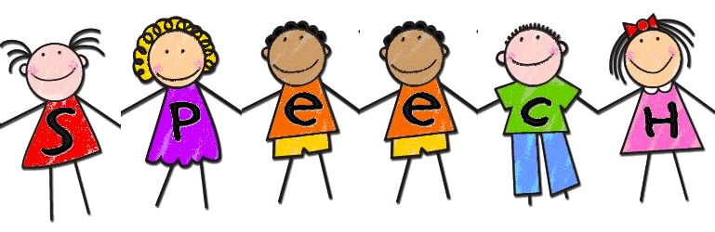

Physical Development
In P.E., we will be exploring dance. We will be using a range of different moves to interpret music and we will be looking for our own spaces and travelling along our own pathways. We will also learn to use a range of equipment – i.e. ribbons, hoops etc to help us with our dance moves.
We will use one handed tools and equipment including construction and malleable materials safely and with increasing control. We will be focussing on developing both gross motor control and fine motor control using both large and small equipment including pencils to follow handwriting patterns accurately. 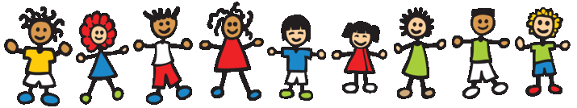

Personal, Social and Emotional Development
Self-confidence and self-awareness: This half term, we will be developing our confidence to ask adults for help, to speak to others about their own needs, wants, interests and opinions. We will be learning strategies to help develop our independence in the classroom space and around school. We will be thinking about our strengths and areas for development.

Managing feelings and behaviours: We will begin to think about accepting the needs of others, learn how to take turns and share resources – sometimes with support. We will begin to be able to negotiate and solve problems effectively. We will learn how to work as part of a group and we will learn to stop and think before acting and develop patience. Our focus will be managing anger.

Making relationships: We will demonstrate friendly behaviour, initiating conversations and forming good relationships with peers and familiar adults in the school setting. We will initiate conversations, attend to and take account of what others say. We will learn to play co-operatively and we will understand that someone else’s point of view can be different from our own. 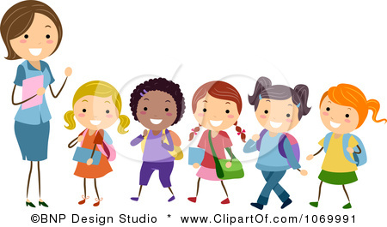

Why is water wet?
Reflections


