WEST TYNE FEDERATION OF SCHOOLS
Marking and Feedback Policy
Our Identity…..
‘God doesn’t want us to be shy with his gifts, but bold and loving and sensible’ 2 Timothy 1:7
Our Vision..... Inspire, Support, Believe, Achieve
Our Mission......
Our values-based schools nurture curiosity and creativity through an inspiring, broad and engaging curriculum, where learning is at the heart of all that we do. Our children learn to become resilient and self-assured in an environment where safety is paramount. Everyone is challenged and encouraged to thrive and achieve as individuals, preparing them for their role as caring and active citizens in modern Britain.
The Federation is committed to the personal development of all involved and aim to provide life- long learning.
We aim to provide extended facilities in both our schools in order to support each child on their learning journey.
Introduction
“Feedback is one of the most powerful influences on learning and achievement”
Hattie and Timperley, 2007

At Greenhead and Henshaw Schools, we recognise the importance of feedback as part of the teaching and learning cycle, and aim to maximise the effectiveness of its use. However, we are also mindful of the workload implications of written marking, and of the research surrounding effective feedback.

Our policy is underpinned by evidence of best practice from the Education Endowment Foundation whose research shows that effective feedback should:
- Redirect or refocus either the teacher’s or the learner’s actions to achieve a goal
- Be specific accurate and clear
- Encourage and support further effort
- Be given sparingly so that it is meaningful
- Provide specific guidance on how to improve and not just tell students when they are wrong
As the Department for Education’s research into teacher workload has highlighted written marking as a key contributing factor, we aim to find alternatives to onerous written marking which provide effective feedback in line with the EEF’s recommendations, and those of the DfE’s expert group which emphasises that marking should be: meaningful, manageable and motivating. We have also taken the advice provided by the NCETM (National Centre for Excellence in Teaching Mathematics) that the most important activity for teachers is the teaching itself, supported by the design and preparation of lessons.

Key Principles
Our policy on feedback has at its core a number of principles to ensure that it is both manageable and sustainable:
- the sole focus of feedback and marking should be to further children’s learning;
- evidence of feedback and marking is incidental to the process; we do not provide additional evidence for external verification;
- written comments should only be used where they are accessible to students according to age and ability;
- feedback delivered closest to the point of action is most effective, and as such feedback delivered in lessons is more effective than comments provided at a later date;
- feedback is part of assessment processes in the classroom, and takes many forms other than written comments;
- feedback is a part of the school’s wider assessment processes which aim to provide and appropriate level of challenge to pupils in lessons, allowing them to make good progress;
- all pupils’ work should be reviewed by teachers at the earliest appropriate opportunity so that it impacts on future learning. When work is reviewed, it should be acknowledged in books.
Within these principles, our aim is to make use of the good practice approaches outlined by the EEF toolkit to ensure that children are provided with timely and purposeful feedback that furthers their learning, and that teachers are able to gather feedback and assessments that enable them to adjust their teaching both within and across a sequence of lessons.
We believe that pupil’s self-esteem and resilience will develop through positive yet challenging feedback. As a result, this will accelerate progress. For this reason, all marking and feedback is underpinned by this policy, which all pupils and staff follow on a day to day basis.
Feedback and Marking in Practice
It is vital that teachers evaluate the work that children undertake in lessons and use the information obtained from this to adjust their teaching. Based on the work of the Assessment Commission, feedback will be given in three ways and aims to give teachers the ability to use the most effective forms of feedback:
- Immediate feedback – at the point of teaching
- Summary feedback – at the end of a lesson/task
- Review feedback – away from the point of teaching (including written comments)
The stages are deliberately numbered in order of priority, noting that feedback closest to the point of teaching and learning is likely to be most effective in driving further improvement and learning. At Greenhead and Henshaw Schools this can be seen in the following practices:
Type | What it looks like | Evidence (for observers)
Immediate | - Includes teacher gathering and providing feedback from teaching (whiteboards, book work etc)  - Takes place in lessons with individuals or small groups  - Often given verbally to pupils for immediate action  - Given by CT and TA to provide support or further challenge (real focus on pupil premium)  - May re-direct the focus of teaching or the task (through effective questioning , mini-plenaries)  - Include highlighting/annotations according to the marking code | - Lesson observations/ learning walks  - Some evidence of annotations or use of marking code/ highlighting
Summary | - Often takes place at the end of a lesson or activity  - Often involves whole groups or classes  - Provides an opportunity for evaluation of learning in the lesson  - May take the form of self or peer-assessment against an agreed set of criteria  - May guide a teacher’s further use of review feedback, focusing on areas of need | - Lesson observations/learning walks  - Evidence of self and peer-assessment  - May be reflected in selected focus review feedback (marking)
Review | - Takes place away from the point of teaching  - May involve written comments/ annotations for pupils to read/ respond to  - Provides teachers with opportunities for assessment of understanding  - Leads to adaptation of future lessons through planning, grouping or adaptation of tasks  - May lead to targets being set for pupils’ future attention or immediate action  - Pupil premium reviewed first | - Acknowledgement of work completed  - Written comments and appropriate responses/actions taken  - Adaptation to teaching sequences  - Use of annotations
Light touch/acknowledgment marking
All work will be acknowledged in some form by class teachers or teaching assistants. This may be through simple symbols such as ticks, stickers, stamps, merits or by highlighting the learning intention/enquiry question. Where a child has achieved the intended outcome and is well-prepared for the next stage in learning, this needs to be acknowledged.

Developmental/Quality Marking
In most cases, written comments will be focused on extended pieces of written work, or extended tasks. These will allow children’s achievements to be recognised and provide further guidance for future learning.
A green highlighted bar will highlight the successes along with a brief comment – children need precise and specific praise.
A pink highlighted bar will be followed by a focused comment which should help the child ‘close the gap’ between what they have achieved and what they could have achieved e.g.
- Reminder – most suitable for high achievers. What else could you say about … Explain your thinking about …. Add more detail to ….
- Scaffold – most suitable for children needing a little more support – provide examples of what they need to do. Ask questions or provide unfinished sentences.
- Example prompt – suitable for all, especially lower abilities. Give children a choice of words or phrases e.g. choose one of these words instead of bad …
- Modelled Example – a correct example modelled by a teacher/teaching assistant with a further one for the child to try.
- Open Question – pose an open question specifically related to the LO to think about next steps.
- Greater Depth/Explanation – use to extend a child’s learning by asking them to explain their learning or reflect on the process or strategies they have used.
5 Stages of giving feedback
- Showing success (highlight in green – green is great)
- Indicating improvement/next steps (highlight in pink – pink to think)
- Giving an improvement suggestion (question, specific task)
- Making the improvement (pink pen)
- Checking the improvement (teacher responds)
Stages 1 and 2 – highlighting should be related to the learning. It can be done during or after the lesson. The most effective feedback is oral feedback after which pupils should take immediate action.
Stage 3 – it isn’t feasible to expect teachers to give all pupils verbal feedback during every lesson, so self-assessment, peer assessment or teacher developmental/quality marking can occur.
Stage 4 – it is essential that time is given for children to respond to prompts, thus enabling them to ‘close the gap’ and improve their work. Dedicated time for making improvements needs to be planned. Children should use pink pens and are expected to edit and improve their work against non-negotiables/prompts/ editing station criteria.
Stage 5 – teachers and teaching assistants check that the improvement has been done (annotation, initial, stamper)
Strategies
Maths

Stages 1 and 2 – Showing success/indicating improvement
Answers to problems are available. After 4 or 5 calculations, pupils check their work and, if they have a misconception, they can alert the teacher immediately while others feel more confident and more willing to move on to the next level of challenge. Having answers available places the emphasis on the learner to check their work and identify their own errors. Teachers and teaching assistants give oral feedback/small tick throughout the lesson.

Stage 3 – Giving an improvement
As part of the learning process teachers will model ways of checking and correcting e.g. repeat a calculation using a pink pen and a different strategy (numbers in a different order, inverse operations etc). Prompt sheets (see below), shared at the beginning of the lesson as an error-spotting checklist, further increase children’s independence and responsibility for their own learning. It is key that pupils internalise this over the course of several lessons so that they no longer need a written checklist. 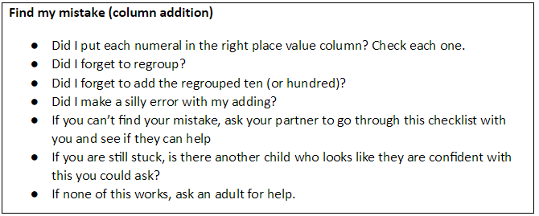
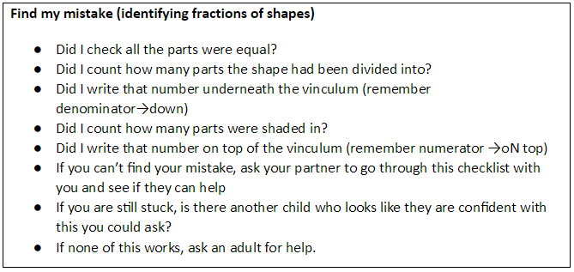
Stage 4 – Making the improvement
Children are expected to respond immediately to verbal feedback within the lesson. Time will be allocated at the beginning of the next session for children to respond to review marking which will focus on any aspects children have not been able to self-correct. Teachers will identify common misconceptions and use these to generate starter activities; consolidation/challenge and the focus children for the following lesson (see appendices).
In addition to this, teachers will mark problem solving/reasoning activities in more depth with a focus on strategies and approaches.
Writing
Stages 1 and 2 – Showing success/indicating improvement Teachers and teaching assistants give frequent oral feedback/highlighting throughout the lesson while children are engaged and focused on the learning process. Through this, and review marking, teachers will identify children and common misconceptions and make these a priority focus in the following lesson (see appendices).

Stage 3 and 4 – Giving and making an improvement
Time will be allocated during the next session (this may be the whole session depending on the age and ability of the children). As part of the learning process, teachers will model ways of checking and correcting eg using pupils’ work to showcase success and show children how to improve. Prompt sheets/editing stations, shared at the beginning of the lesson, further increase children’s independence and responsibility for their own learning. Children work in pairs to both edit and improve their work using pink pen, completing challenges/ think pink on the left hand side of the page..

In-depth marking will take place after the final independent writing piece using the marking code (See Appendices) to address basic skills, grammar objectives, and the relevant year group marking ladder. These pieces should be given more detailed written feedback.

Right on the right
Children must write on the right hand side of every book. They may edit this work on the right if it is a small correction but a piece of edited pros, a think pink challenge or a response to the teachers marking must go onto the left.

Foundation Subjects
These should be marked regularly in a way appropriate to the task and learning intention– this can take the form of written, verbal, peer or self-assessment.

Differentiated Marking
The key element to our marking approach is the assumption that all children can work independently given prior input: increase the amount of intervention only if they really cannot get on without it and ensure it is in addition to, and not instead of, the teacher modelling editing before the independent section of the lesson.
Some children will need also need a prompt to narrow their focus when editing (a pointer – description, figurative language) while others will need more support in the form of a clue (draw a box around the section to edit with the clue, e.g. speech marks, tenses ). If mistakes are deeply entrenched the teacher will do some direct modelling e.g. addressing confusion with apostrophe use.
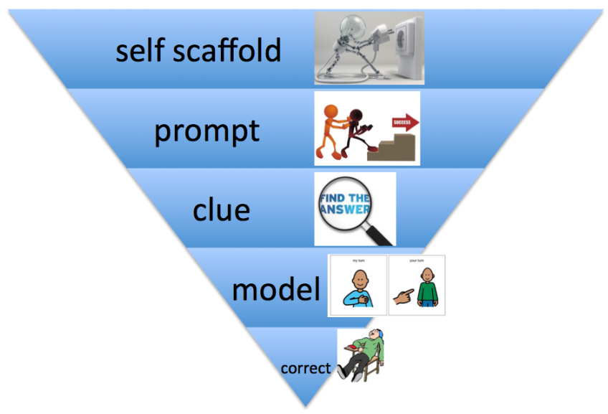
Children as Markers (Self and Peer Assessment)
Self and peer assessment have a key role to play in effective marking and feedback – they empower children to take control of their own learning.
Self Assessment
Before any child hands in any piece of work for marking they should spend an appropriate amount of time checking they have considered the non-negotiables and prompt sheets. This time will be planned in as part of the self-assessment time either before the end of the lesson or as a focus of the next lesson, whichever is most appropriate for the task (see strategies).
Peer Assessment
Children peer assess using the agreed prompt sheets and marking codes. Peer assessment should begin in Y2 and modelled by the class teacher using visual aids or appropriate strategies.
Target Setting
A significant aim of feedback is to ensure that children are able to identify how they can improve their work or further their learning. In some cases, targets are clearly set out through use of the marking code and accompanying comments.

In mathematics, targets for all pupils are based on the key number skills needed for each stage of learning that underpin broader mathematics learning, including number bonds, multiplication facts and standard written methods.
In English, formal targets are drawn from the school’s Key Objective NC assessment framework in KS1 and 2 and from the ‘Developmental Matters’ documentation for EYFS.
Targets should be reviewed regularly by both pupils and teachers, and updated when they are achieved. Where targets remain for a long period, these should be reviewed to take account of a child’s needs and progress.
Marking codes
Where written marking or annotations are appropriate, the intention is that minimum teacher time should lead to maximum outcomes. Teachers should complete a grid for maths, English, RE and science (See appendix 3) Marking codes, combining the use of highlighters and symbols, have been developed for consistent use across the school to make feedback accessible for children and to make marking and feedback manageable for teachers (see appendices) although some additional age-appropriate elements may be included in some phases of the school.
Marking codes should be displayed in class, shared with children and used by children during peer assessment.

Policy Monitoring, Review and Evaluation
Marking and feedback will be closely monitored by subject leaders, SLT and Governors through:
- Lesson observations/learning walks
- Book scrutiny
- Pupil discussion
- Moderation
The policy will be reviewed termly during the 2018/19 academic year by subject leaders and all staff to ensure that it is effective and workable before being finalised.

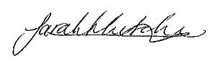
Signed: Date: September 2019
Executive Headteacher
Review Date: September 2020

Appendix 1: Written marking codes
The coding must be available to children and staff in the classroom to check regularly.
Review marking should be completed neatly in GREEN pen using the agreed school script.
Margin  Symbol | Meaning
p | Correct punctuation (sometimes accompanied by clue eg - CL . ! ? , : ; ‘ “ )
g | Correct the grammar
sp | Correct the spelling using a resource (eg word mat, working wall, dictionary)
v | Improve the vocabulary
 | Add in the omitted word
\\ NP | Insert to show where a new paragraph should be
 | Incorrect word usage
 | Find the error on this line and edit/improve (summer term)
green highlighted bar | Impressive punctuation, vocabulary, conjunction, opener, use of clauses
E | Identifies section that does not make sense or needs editing and improving
green highlighted bar at end of review | Praise and precise comment relating to achievement relating to LI
pink highlighted bar at end of review | Identifies a precise area for improvement. Either a correction, more practise or something to edit/improve

Appendix 2: RE Feedback record sheet KS1/KS2 VF form to inform future planning:
Date: | Subject: | LO:
Key misconceptions to be revisited tomorrow: |  | Focus pupils and focus area for tomorrow:
Date: | Subject: | LO:
Key misconceptions to be revisited tomorrow: |  | Focus pupils and focus area for tomorrow:
Date: | Subject: | LO:
Key misconceptions to be revisited tomorrow: |  | Focus pupils and focus area for tomorrow:
Date: | Subject: | LO:
Key misconceptions to be revisited tomorrow: |  | Focus pupils and focus area for tomorrow:
Date: | Subject: | LO:
Key misconceptions to be revisited tomorrow: |  | Focus pupils and focus area for tomorrow:

Appendix 3- English Feedback record sheet KS1/KS2 VF form to inform future planning:
Next steps in lesson: |  | Misconceptions/errors:
 |  | Need further support:
 |  | Star performers:
Good examples: | Presentation issues: |  | Incomplete:

Appendix 4- Teaching and Learning grid for Maths, English and Science
Learning objective:  Link to NC statement to inform tracker (if applicable) |  | Date: Year  Supported work  Independent work
Success criteria: | Self-assessment | Peer assessment | Teacher assessment
yes/no

Appendix 5- Maths KS1 VF form
Date: | Teacher:
Learning objective:

Misconceptions (add child’s name and tick once discussed)
Year 1 | Year 2
More able (include further challenge if appropriate)
Year 1 | Year 2
Other: Incomplete, presentation issues, basic skills etc…
Year 1 | Year 2
Actions needed by the teacher (tick when planning has been evaluated and amended)

Appendix 6- Maths KS2 VF form
Date: |  | Teacher:
Objective:

Misconceptions (add child’s name and tick once discussed)
Year 3 | Year 4 | Year 5 | Year 6
More able (include further challenge if appropriate)
Year 3 | Year 4 | Year 5 | Year 6
Other: Incomplete, presentation issues, basic skills etc…
Year 3 | Year 4 | Year 5 | Year 6
Actions needed by the teacher (tick when planning has been evaluated and amended)

Appendix 7 – Teaching and Learning grid for RE

Learning objective: To answer a Big question…. |  |  | Date:
Success criteria: |  | Self-assessment | Peer assessment | Teacher assessment
Independent work | Supported work | Teacher comment based on learning objective:  Q  Response to question….
Don’t forget:  Date, title and underline  Presentation of work  Complete all work set  Respond to feedback | To practice:

Appendix 8- EYFS

Date: |  | Teacher:
Area of learning (please circle-could be more than one)
communication and language physical development personal, social and emotional development literacy mathematics understanding the world expressive arts and design
Objective:

Success criteria:

Misconceptions (include child’s name and misconception and ticked once discussed
Emerging | Developing |  | Secure
More able (Include further challenge if appropriate)
Emerging | Developing |  | Secure
Other: Incomplete, presentation, basic skills etc.
Emerging | Developing |  | Secure
Active Learning (motivation) | Playing and Exploring (engagement) |  | Creating and Thinking critically (thinking)
Actions needed by the teacher (tick when planning has been amended)

•Active Learning (motivation): Being involved and concentrating; enjoying achieving what they set out to do; keeping on trying. Playing and Exploring (engagement): Being willing to have a go; finding out and exploring; playing with what they know.
•Playing and Exploring (engagement): Being willing to have a go; finding out and exploring; playing with what they know. Creating and Thinking Critically (thinking): having their own ideas; making links; choosing ways to do things.
•Creating and Thinking Critically (thinking): having their own ideas; making links; choosing ways to do things.

