Maths in Year 2
- Count in steps of 2s, 3s and 5s, and steps of 10
- Recognise place value in two-digit number
- Compare and order numbers up to 100 using <, > and =
- Recall and use addition/subtraction facts to 20, and derive related facts
- Add mentally and with objects one- and two-digit numbers
- Subtract mentally and with objects one- and two-digit numbers
- Use the inverse relationship between addition and subtraction
- Know 2×, 5× and 10× tables
- Recognise odd & even numbers
- Calculate mathematical statements using x and ÷ symbols
- Find, name and write 1/3, 1/4, 1/2 and 3/4 of size, shape or quantity
- Write simple fraction facts, e.g. 1/2 of 6 = 3
- Combine amounts of money to make a value, including using £ and p
- Tell the time to the nearest 5 minutes, including drawing clocks
- Describe properties of 2-D shapes; number of sides and symmetry
- Describe properties of 3-D shapes; number of edges, vertices and faces
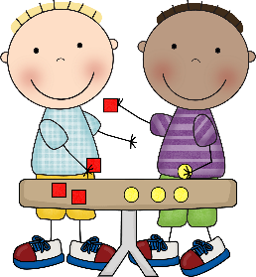
- Interpret and construct simple tables, tally charts and pictograms

