English  Our class texts are books by Roald Dahl – our significant author.  Our guided reading text is ‘The Warrior Princess’ by Saviour Poretta.  Our writing styles for this half-term are:  Newspaper reports  Diaries  Riddles | R.E.  Our thematic learning in R.E. this half-term poses the question: How and why do believers show their commitments during the journey of life?  We will be identifying:  Some beliefs about love, commitments and promises in different religious traditions;  Ceremonies of commitment for religious and non-religious people;  How people in two different religions live and how/what they celebrate.  Identifying similarities and differences in religious ceremonies and beliefs. |  | Maths  In Maths during this half-term, our objectives will focus on  properties of shape and statistics:  We will be learning to:  • Read and interpret bar charts, pictograms and line  graphs  • Draw our own bar charts and pictograms  • Name angles  • Compare and order angles  • Understand vertical and horizontal lines, including  parallel and perpendicular lines  • Draw 2D and 3D shapes  • Name quadrilateral shapes |  | History  In history, we are finding out about the Roman Empire and its impact on Britain.  We will be learning about:  Growth and Expansion of the Roman Empire. The First Invasions of Britain;  Emperors of the Empire (Local History Focus- Hadrian)  Roman Army and the Conquest of Britain;  Boudicca’s Rebellion;  Struggle with Scotland and Hadrian’s Wall;  Roman withdrawal;
PSHE/RSE  This is all about ‘Changes’. We will be looking at:  Personal identities and qualities – achievements and interests.  Managing feelings and coping with setbacks – building resilience;  Changes into puberty;  Discussing and being able to express feelings;  Coping with feelings – hopes and fears as children transition to new classroom/teacher. | The Rhine  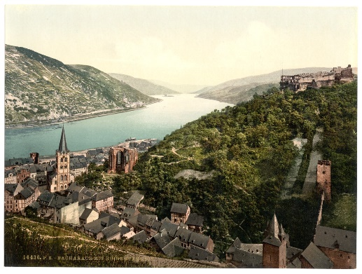  Curriculum Grid  Summer 2  Y3/4 |  | Science  In science this half-term, we will be finding out about light, shadow and electricity.  We will be learning to:  Year 3:  Recognise that they need light in order to see things and that dark is the absence of light  Identify and Classify – Light Sources and reflectors  Opaque, Transparent and Translucent  To recognise that shadows are formed when the light from a light source is blocked by a solid object.  To recognise that light comes from the sun and can be dangerous and that there are ways to protect the eyes.  Year 4:  To know common appliances that run on electricity  To construct simple series electrical circuits identifying and naming basic parts including cells, wire
French  In French, this half-term, we will be learning about La Famille. This will include:  Learning the nouns of family members;  Possessive adjectives ma, mon, mes;  Ask and answer questions about them – i.e. age, name, etc. | Art  In art, this half-term, we are going to be continuing our work on mosaics and create a mosaic for our school grounds based on our values. We will also look at the artwork of Romans and other significant artists. We will develop the skills needed. | Music  Music will be focused around the song Lean on Me by Bill Withers. We will be listening and appraising a range of music from a range of eras – from classical, gospel and pop. We will be using the correct musical language and looking at similarities and differences between the styles chosen. |  | Computing  In computing, we are going to be making things happen by:  Understanding the importance of clear and precise instructions; Using algorithms to control movement. Creating and debugging simple programs and using control commands to draw simple shapes. | P.E.  In P.E. this half-term, we will be focusing on athletics in preparation for our sport’s day at the Wentworth Centre.  Children will need to come in their P.E. kits on Monday and Wednesday each week.

