Maths in Year 4
- Count backwards through zero, including negative numbers
- Recognise place value in four-digit numbers
- Add and subtract 4 digit numbers
- Round any number to the nearest 10, 100 or 1000
- Know tables up to 12 × 12
- Use place value and number facts to carry out mental calculations
- Use factor pairs and commutativity in mental calculations
- Use short multiplication method
- Recognise and use hundredths
- Recognise and write decimal equivalents to ¼, ½ and ¾
- Divide one- or two-digit numbers by 10 and 100, using tenths and hundredths
- Round decimals with one decimal place to the nearest whole number
- Compare numbers up to two decimal places
- Convert between different units of metric measurement, including money
- Find the area of rectilinear shapes by counting squares
- Solve problems converting units of time
- Compare and classify shapes, including quadrilaterals and triangles
- Complete a simple symmetric figure with respect to a specific line of symmetry
- Describe positions on a 2-D grid using co-ordinates
- Describe translations using a given unit to the left/right and up/down
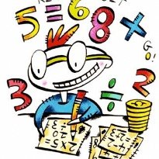
- Interpret and present discrete and continuous data on appropriate graphs

