Key studies within Music in Lower Key Stage 2
Let Your Spirit Fly
- I can explore RnB and other styles (Film, Musicals, Motown and Soul) and join in in different ways (singing, playing percussion, playing glockenspiels).
Glockenspiel 1
- I can explore and develop my playing skills on the glockenspiel.
Three Little Birds
- I can learn about Bob Marley and use Reggae music to explore the themes of happiness and animals.
The Dragon Song
- I can explore folk music from around the world (China, India, Polynesia, Turkey and Sudan) and talk about kindness, respect and friendship.
Mamma Mia
- I can explore the music of ABBA and join in in different ways (singing, choreographed dancing, playing tuned instruments).
Stop
- I can explore a range of styles (rap, grime, hip-hop, classical, funk and soul) and compose my own lyrics to perform with a backing track.
Lean On Me
- I can explore soul and gospel music.
Blackbird
- I can learn about The Beatles and explore their music.
Reflect, Review, Rewind
- I can evaluate classical music from different composers and eras (Handel, Beethoven, Gershwin and Glass).
Music in Year 3
- I can sing 5 songs from memory.
- I can talk about 1 song in detail (explaining style, instruments, dimensions).
- I can start to find musical dimensions featured in songs (texture, pitch, rhythm, tempo, dynamics).
- I can play along and move to the pulse in different pieces of music (using my body and instruments).
- I can explain how the pulse, rhythm and pitch work together.
- I can sing along to music on my own, in small groups and as a whole school.
- I can play a simple melody to music (on a glockenspiel or recorder).
- I can explain what improvisation is and improvise with a backing track using between 2 and 5 different notes.
- I can compose a simple melody and record it using letter names or notation.
- I can perform music in my lessons and to the rest of the school.
- I can talk about feelings and themes related to different musical styles and think about these when performing.
Music in Year 4
As above and …
- I can start to use a range of musical words when talking about songs (keyboard, electric guitar, bass, drums, piano, organ, acoustic guitar, recorder, glockenspiel, percussion, improvise, melody, pulse, rhythm, pitch, tempo, dynamics, texture, structure, compose, hook, riff, verse, chorus, introduction, solo, pentatonic scale, unison, rhythm patterns, musical style, rapping, lyrics, choreography, digital/electronic sounds, turntables, synthesizers, by ear, notation, backing vocal).
- I can keep an internal pulse when listening and playing.
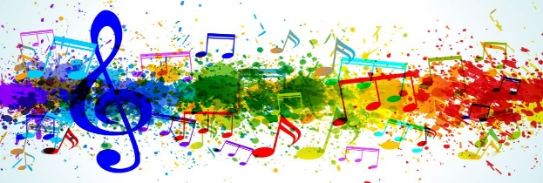
- I can start to hear and talk about a wider range of instruments that may be played in a band or orchestra (eg. violin, cello, clarinet, trumpet, bass guitar).

